**THE USE OF CROWDSOURCING BY CREATING A MOBILE APPLICATION TO MAKE OUR UNIVERSITY A BETTER ENVIRONMENT**

**GEETH WIHANGA YAPA SENEVIRATHNA BORALESSA**

**SEU/IS/15/ICT/015**

**REPORT**

**NATION DEVELOPMENT PROJECT**

**Department of Information and Communication Technology Faculty of Technology**

**South Eastern University of Sri Lanka**

**2019**

## Abstraction

<Write the brief synopsis of the project>

## Acknowledgement

I would like to take this opportunity to express my profound sense of gratitude and respect to all those who helped me throughout the duration of this Nation development project.

Therefore firstly, I would like to give my heartiest gratitude to our Nation development project coordinator senior lecturer MR. RK. Ahmadh Rifai Kariapper, Department of Information and Communication Technology, Faculty of Technology, South Eastern University of Sri Lanka for his support and guidance throughout the project period and members of the staff of department Of Information and Communication Technology.

A special gratitude I give to my project supervisor Mrs. A.Fathima Musfira, Department of Information and Communication Technology, Faculty of Technology, South Eastern University of Sri Lanka whose contribution in stimulating suggestions and encouragement, helped me to coordinate my project especially in writing this report and invested her full effort in guiding me in achieving the goal.

Last but not least, many thanks go to my friend Oshan Fernando, Associate Software Engineer, Wiley Global Technology Pvt. Ltd. who helped me to assemble the parts and gave suggestions about the nature of the mobile application.

## TABLE OF CONTENT

Abstraction ii

Acknowledgement iii

Table of content iv

List of figures vii

CHAPTER 01 – INTRODUCTION

* 1. Introduction 01
  2. Goals and Objectives 02
  3. Motivation 02
  4. Scope of the completed project 02
  5. Approach while carrying out the project 03
  6. Concise summary of the major outcomes 03

CHAPTER 02 - BACKGROUNG

* 1. Identified problem and the motivation 04
  2. Constraints and limitations 04
  3. Existing approach and their in-capabilities 05

CHAPTER 03 - ANALYSIS

* 1. Introduction 06
  2. Functional requirements 06
  3. Non-functional requirements 07

CHAPTER 04 – SPECIFICATION AND DESIGN

* 1. Use case diagram 08
  2. ER diagram 10

4.4 Interface design 11

4.3 Database design 11

CHAPTER 05 - IMPLEMENTATION

* 1. Introduction 12
     1. Technologies used in implementation 12
  2. Software and Hardware requirements 12
     1. Software requirements 12
     2. Hardware requirements 12
     3. Server requirements 12
  3. Implementing security 13

CHAPTER 06 – RESULTS AND EVALUATION

* 1. Introduction 14
  2. System test plan 14
     1. Functional testing 14
     2. Interface testing 14
     3. Database testing 15
  3. Test cases and test results 15
     1. Test cases for testing accurate user login 15
     2. Test cases for accurate point calculation for users……………. 15

CHAPTER 07 – FUTURE WORK

7.1 Future enhancement 16

CHAPTER 08 – CONCLUSION

* 1. Introduction 17
  2. Lessons learnt 17

REFERENCES 18

APPENDIX – DOCUMENTATION 19

## LIST OF FIGURES

## <if any include here>

# CHAPTER 01 – INTRODUCTION

## Introduction

## Tired of seeing our university with wind-blown trash on the grounds, graffiti on restroom doors, and plastic bottles on the university beach? Do the students seem to ignore the problems? How could we grab their attention? How could we motivate them to fix up the environment and keep it clean? How can we motivate students to make positive changes in our university?

## Research has shown that people are more productive, feel safer, and behave kindlier in clean environments, making them better places to live for all of us. Of course, there are certain units to clean and control maintenance in our university. But what if we create a place where everyone can join and support to make the university environment more functional. Why not try using what is in everyone’s pocket- “a smart phone”. With the help of this project I have tried your hand at harnessing the power of crowdsourcing and mobile technology by creating an application that motivates its users to change their university for the betterment. How can we motivate students and let them have the moral satisfaction? *The satisfaction involved in the performance of moral action. This concept is vulnerable to an important objection: if moral action is satisfying. It might only ever be performed for the sake of this satisfaction. (Kant, Immanuel on moral satisfaction)*.

## Recently, scientists and managers have managed to accomplish huge jobs by crowdsourcing. They outsource, or pass on, parts of their tasks to the general public answering an open call to action. The reasons that motivate people to participate in a crowdsourcing campaign can include their desire to contribute in ways that make them feel good about themselves, or a desire to use their knowledge of a specific subject, worldview, or spiritual belief to contribute to a large scale project (something larger they could not do on their own). The prospect of a prize, recognition, or a personal advantage can also be motivational. By that principle this application will motivate its users by rewarding points according to the type of the action which has been done.

## E.g.

## • Trash removal

## • Washing equipment (benches, tables)

## • Beach cleanup

## • Reporting broken equipment

## • Tree plantation

## And at the end of a time period users who have earned the highest points and contributed most to the university environment will be evaluated and honored.

## Goals and Objectives

* The aim to design and develop the project is to Motivate the students of the university to involve in making the university environment a better place.
* Experimenting and testing ‘crowdsourcing’ whether it would success

In the university environment.

* Creating a better university environment to study and live happily.

## Motivation

## What motivated me most to initialize this project is to see a 100% clean and an eco-friendly university which all the students can take part on creating a better university environment.

## And also, I wanted to apply the crowdsourcing theory to the university environment and to check whether it would succeed.

## 

## Scope of the completed project

## To test the product, I have used 10 test cases.

## But the completed project has proven that it can be applied to the university level. Which means all the students of the South Eastern university of Sri Lanka can be benefitted by using this mobile application.

## Not only the students but also the administration of the university can get indirect benefits through this project.

## Approach while carrying out the project

## Concise summary of the major outcomes

At the completion of the project I have tested and proved that crowdsourcing concept can be successfully applied to the university environment. Which means it proved that as the project proposal objectives suggested that by giving the test cases a moral recognition for the work, they have done their active participation can be obtained in order to make the university environment a clean one.

# CHAPTER 02 – BACKGROUND

## Identified problem and the motivation

## South Eastern university is a public university located in the oluvil, Eastern province with a student population of about 4800 students. The university is very well known for its scenic beauty thanks to the and Gal oya to the north and Oluvil beach to the south. My faculty, Faculty of Technology was first located at the port’s authority building in oluvil beach.

## But our hostels, “FVB4” they were located at the other end of the university. So, at the end of the day after lectures we had to travel on foot from this end to that end of the university. While walking I have encountered that at each end of the day there is a significant number of plastic bottles and garbage thrown into the beach and road corners. But the students seemed to ignoring the problem.

## Even though there is a cleaning team inside the university I thought what if there is a way to make students to actively participate into the cleaning of the university environment. So I chose to use crowdsourcing.

## Constraints and limitations

## The design and the interfaces might look simple in the mobile application as I didn’t have any prior knowledge about Android Studio because I was learning at the second year first semester and the study of the creating applications using Android studio comes under third year first semester. I could have created the website using html and converted it to an application easily. But I chose to learn and create using Android studio as it is the standard way of creating applications.

## In order to test the project, I have used AWS free tier server. It is only free for one-year trial. So, after that I would have to obtain a server for a fee.

## Existing approaches and their in-capabilities

**Green Me!**

Green Me is a very basic app which you can be taken to the entry for that particular day. You can enter little notes in the form of bullet points, but only five bullet points can be incorporated.

At the end of the day, or when you make your final entry for the day, you can simply rate yourself in shades of green to mark out just how green you were on that day. This shade of green will be visible in Calendar view as well, so when you have filled out a few days' worth of entries, you'll be able to see how green you've been at a glance. It costs $1.99 to download this app.

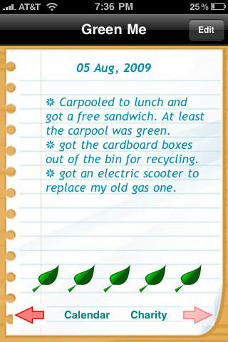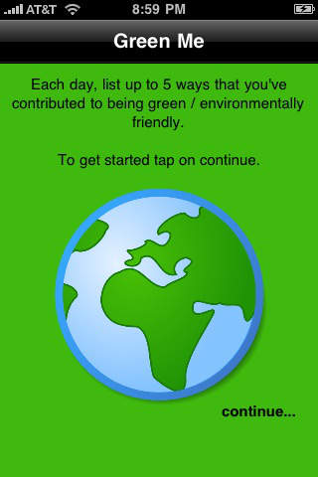

# CHAPTER 03 – ANALYSIS

## Introduction

## Throughout the project I chose to fulfill my main motivation goals of the project, which are to test the crowdsourcing theory inside the university environment and to make the university environment a better place with the help of the students.

## So first I spent my first half of the project time in learning on my own on how to create basic mobile applications through Android Studio and then I created the mobile application. After that in the next half of the project time I used it to test the crowdsourcing theory. So, I chose ten users, gave them accounts and passwords and tested their works throughout a two-week period of time.

## Functional Requirements

## User should be able to enter username and password and login to the application.

## User should be able to witness his/her current points.

## User should be able to log new tasks.

## User should be able to select the task from a set of tasks.

## User should be able to add comments regarding the tasks.

## User should be able to send proof of the task through the application.

## The application should provide each user with different views.

## Non-Functional Requirements

## Reliability

## ▪ The application can be used by the multiple users in the same time

## Availability

## ▪ The mobile application is available for every online customer in 24/7 hours.

## Security

## ▪ Every registered user has to login to the application using own username and password

## Data integrity

## Performance

▪ The application is platform independent  
▪ The User- interface screen will respond within few minutes.

## Responsiveness

## Usability

# CHAPTER 04 – SPECIFICATION & DESIGN

## Use case diagram

## 

## ER diagram

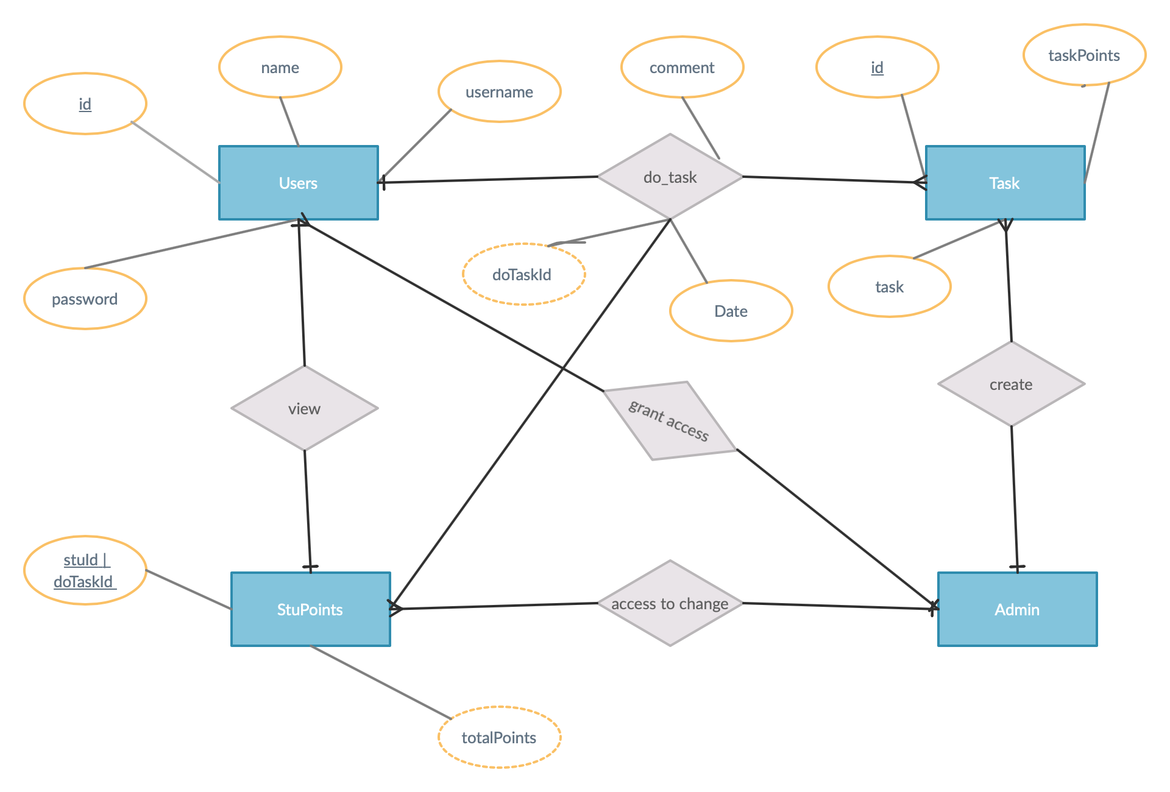

## Interface design

The mobile application “NIYAMU” under the project “GREEN AGNI” has three user interfaces. Basically they can be named as,

* **Login Page**

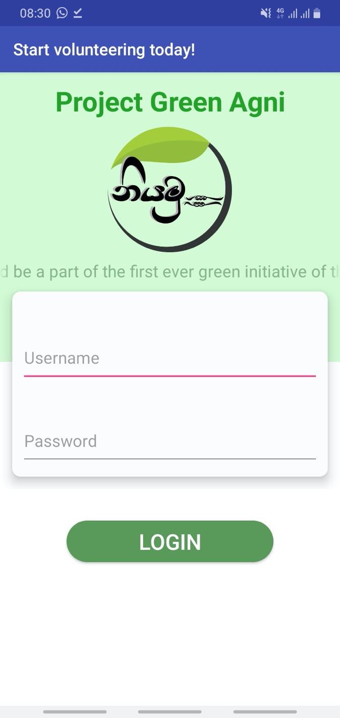

In this interface users can log into the server system using a unique username and password without any failure. If the username or the password is incorrect it will prompt an error message saying “Invalid username or password”.

* **Home page**

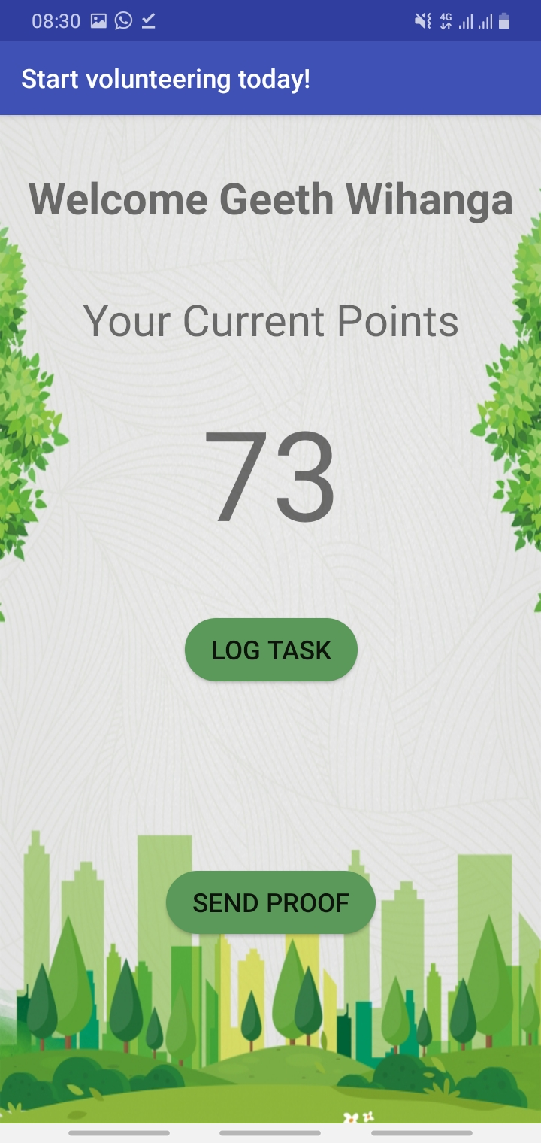

In this interface users can view their current points and move to to the Add task page and also using this, user can send proof to the official project page in Facebook through the application.

* **Add task page**

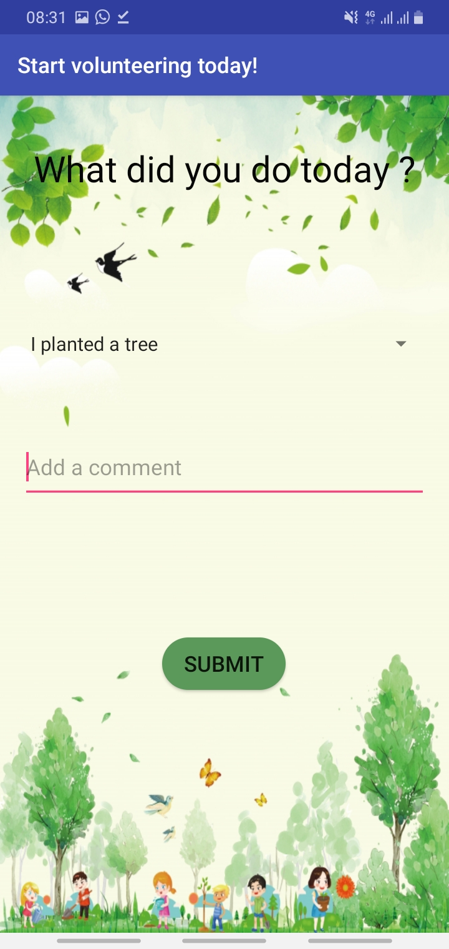

In this interface users can choose between a number of predefined activities which he/she has done in the university environment and also users can send a comment regarding the activity.

## Database design

## In order to keep the user details and to retrieve points I have created the database using MySQL and retrieved points using json. For the server purposes I have used amazon “AWS FREE TIER” services.

## Above is the source code of the database code. And following is the source code when the user logs in to the database.

## 

## And here is the source code of when a user is selecting a task and how the points which is related to that task is created.

## 

# CHAPTER 05 – IMPLEMENTATION

## Introduction

### Technologies used in implementation

Programming the modules was done in the implementation phase and the I have used Java language and Android Studio as the Development platform where MySQL has been chosen as the database management system as well as the JSON retrieve user points. Coding has been done for the data validation as well as for the verification because the mobile application wants to be ensured the accurate data get inserted to the database. In order to verify the ping connectivity of the POST request I have used “Postman” application.

## Software and Hardware requirements

### Software Requirements

|  |  |
| --- | --- |
| Development requirements | Running requirements |
| macOS Catalina version 10.15.2 | Above from Android 8.1 Oreo |
| Android studio version 3.5 |  |
| Postman version 7.9.0 |
| SQLPro for MySQL Version 2020.05 (Build 10487.5) |
| Java virtual machine – Openjdk 64-bit server |

### Hardware Requirements

|  |  |
| --- | --- |
| Development requirements | Running requirements |
| Mmm MacBook Air (13 inch, 2017)Processor - 1.8 GHz Dual-Core Intel Core i5Memory - 8 GB 1600 MHz DDR3Required space for project – about 4GB memory space | Samsung galaxy A10SOS – Android 9.0 (Pie)Memory – 2 GBRequired space for the mobile application – 8MB memory space |

### Server Requirements

### In order to host my application, I have decided to use Amazon AWS free tier EC2 instance. Therefore, I created an account on their website and chose UBUNTU server 20.04 Amazon machine image.

### 

### And then I configured my EC2 instance in the following manner.

### Then after creating role I gave “AdministratorAccess” permission policy to my instance.

### Finally, I configured a security group and launched my instance.

## 

## Implementing security

Security is a major concern when it comes to mobile applications. In this mobile application I have used Basic security like Login security and password validation. Also, I have blocked data redundancy in my database. As this is my initial project I have given out unique passwords for my 25 members to login.

When a user enters a incorrect password, the user will be not allowed into the system.

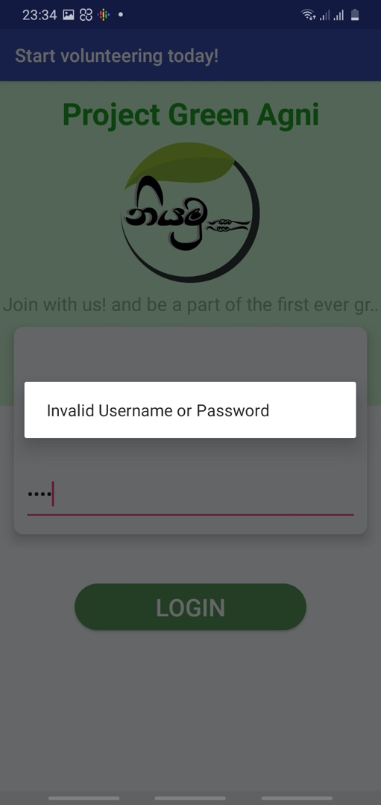

# CHAPTER 06 – RESULTS & EVALUATION

## Introduction

## System Test Plan

### Functional Testing

### Interface Testing

### Database Testing

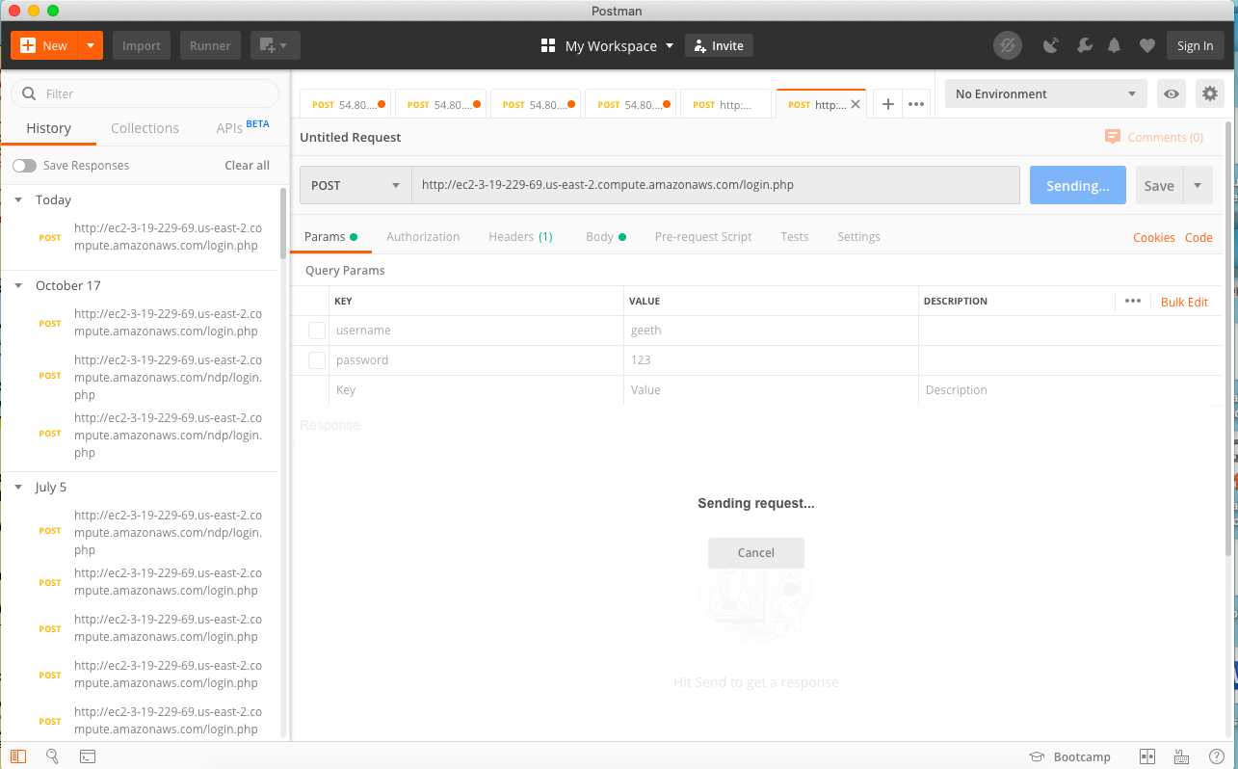.After designing and implementing my database using SQL, then I connected my application with the database using my EC2 key. Then I made sure whether my database is properly connected or not using POSTMAN application by sending JSON requests.

## Test cases and Test results

### Test cases for testing accurate user login

Test case 01: Kasun Rathnayake

Username : kasun

Password : kasun

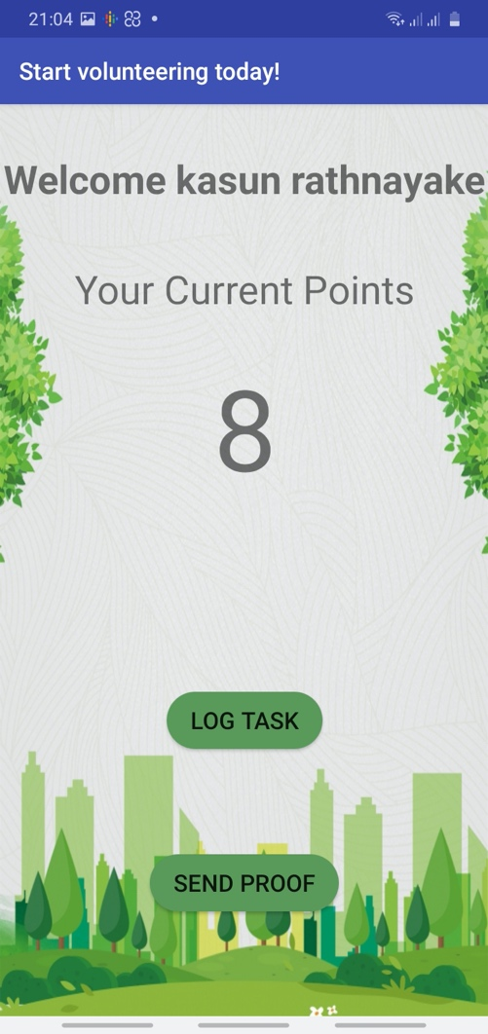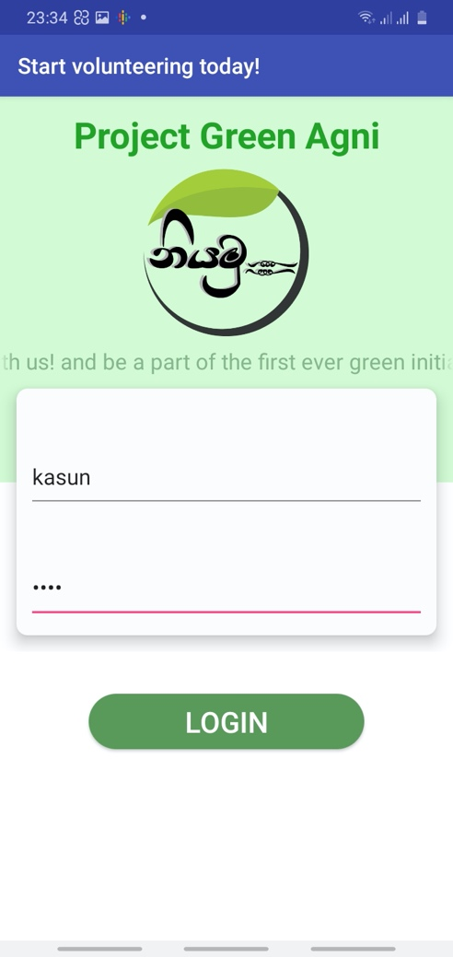

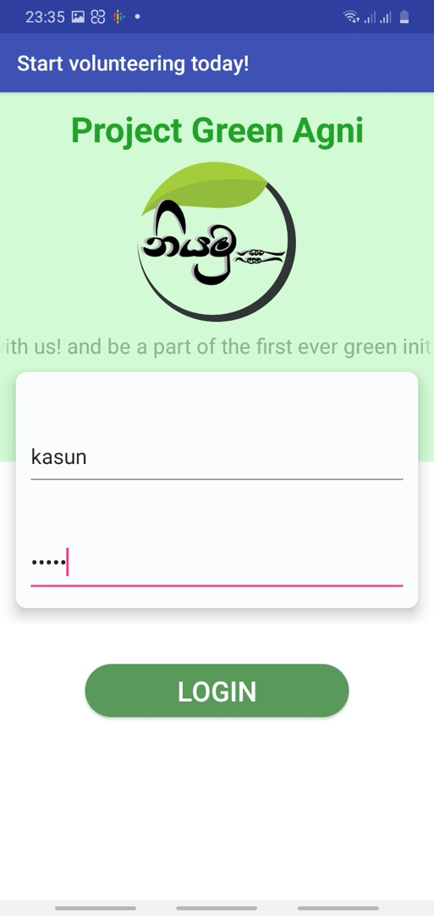

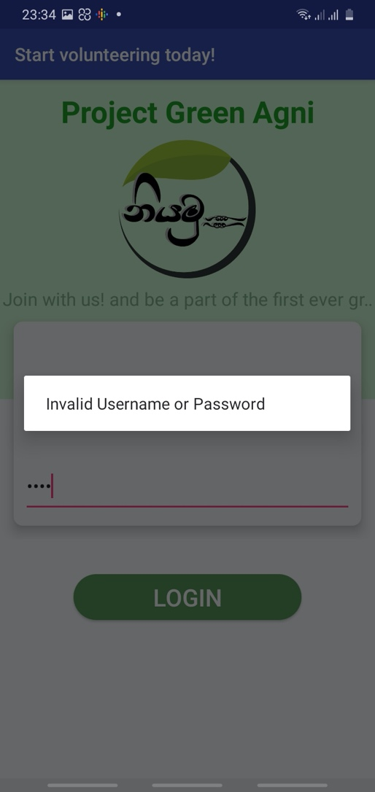

Test case 02: Tilan Neelaruwan

Username : tilan

Password : tilan

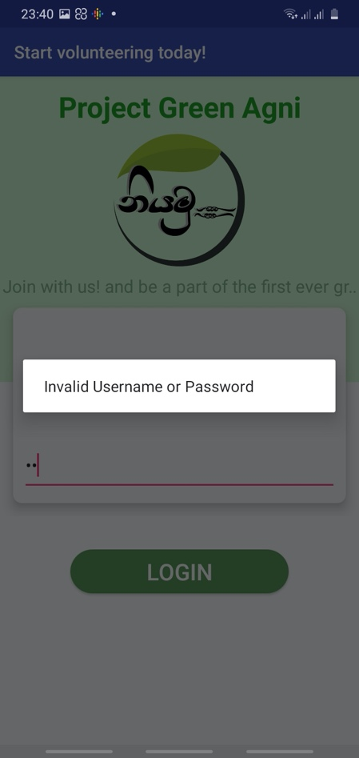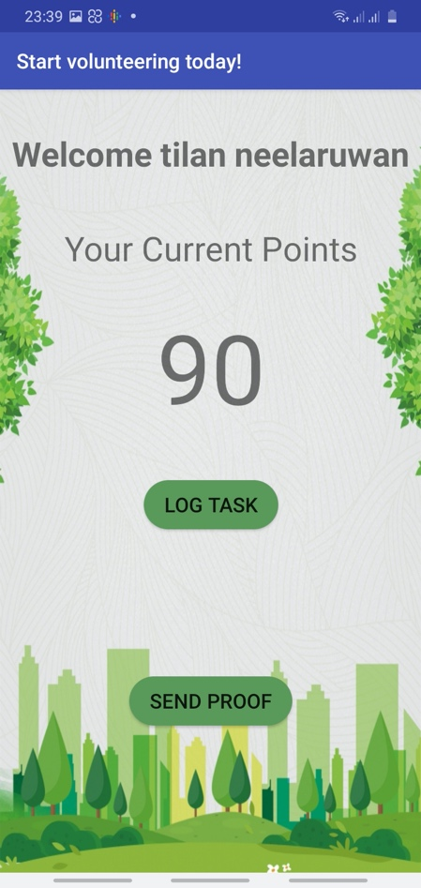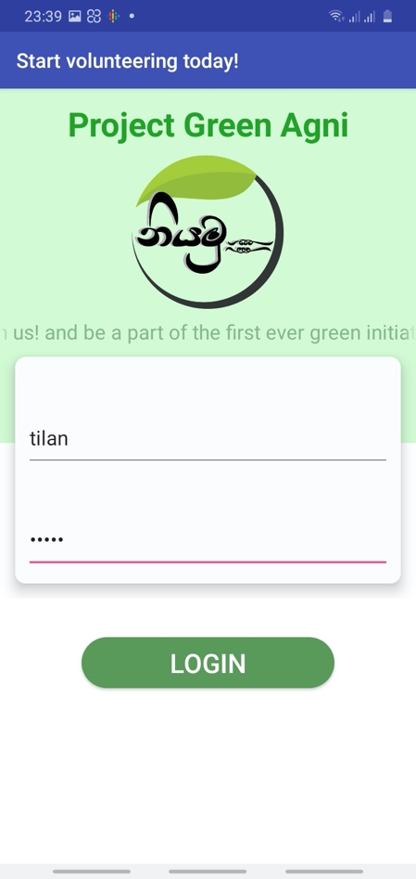

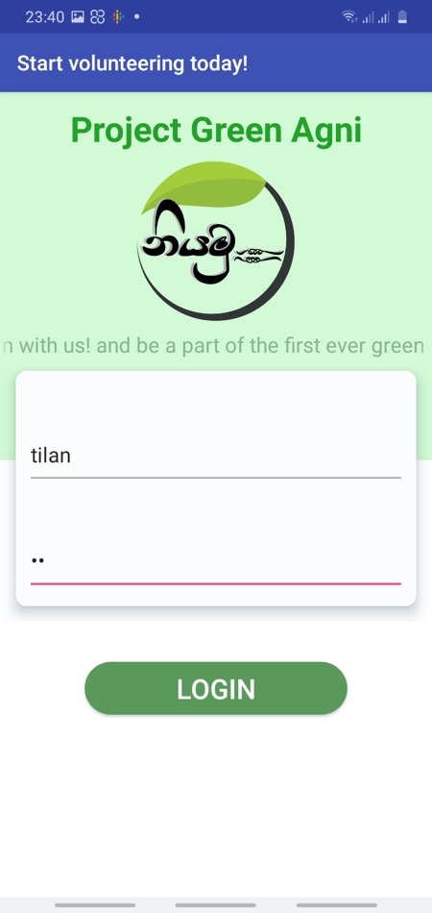

### Test cases for testing accurate point calculation for users

# App View

# 

# Database View

# 

# 

# CHAPTER 07 – FUTURE WORK

## Future enhancement

# CHAPTER 08 – CONCLUTION

## Introduction

.

## Lessons Learnt

## REFERENCES

## APPENDIX - SYSTEM DOCUMENTATION

### Home Page

Following Figure show home page of the website.

### Contact Page

### Login form

### User Registration Form